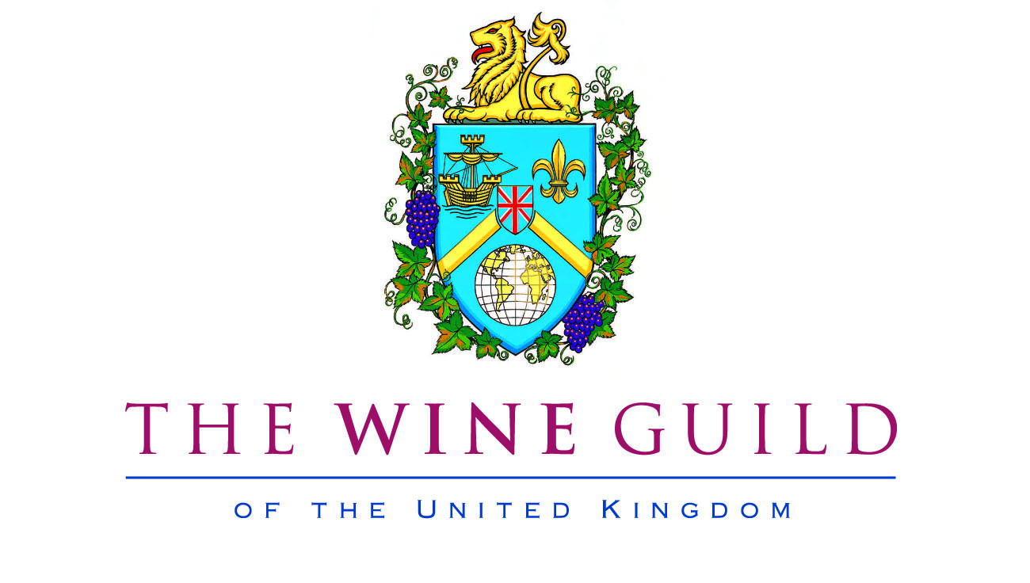

DINNER IN THE HISTORIC WINE CELLARS
OF THE STAFFORD LONDON

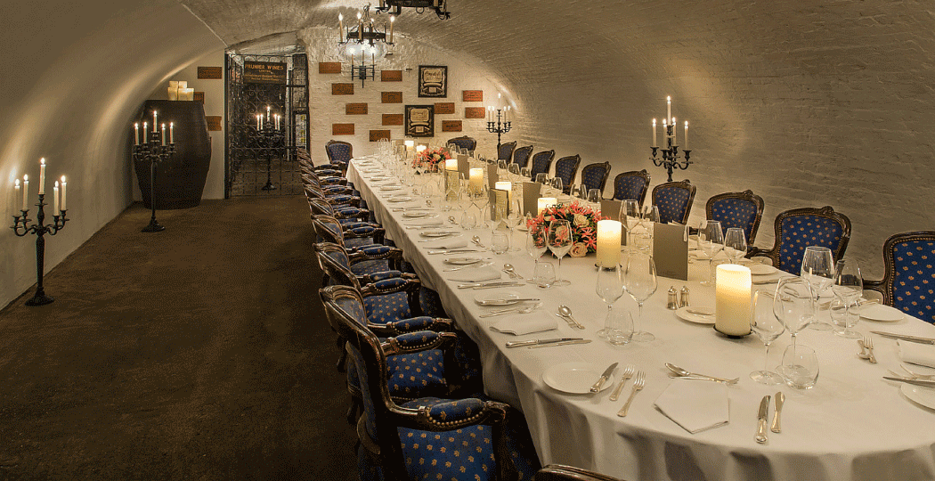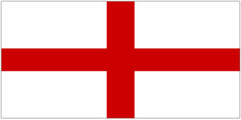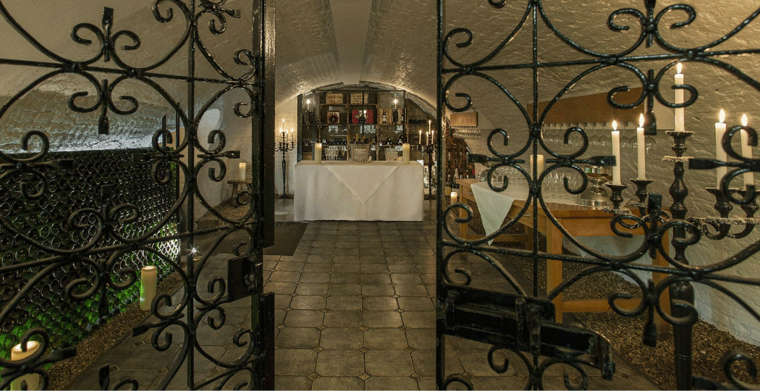

MONDAY, 25TH APRIL 2016
This year we are starting what we hope will become an annual event: a dinner in celebration of St George’s day. It is a wonderful excuse to enjoy a traditional English dinner with food and wines themed on St George and the best of English!

We are delighted that we have been able to secure the atmospheric Cellars at The Stafford in the heart of
St James’ for the occasion and we have agreed the menu with them, which will match simplicity with elegance and quality.

As you might expect, the evening will start with a proud moment: an award winning English (Sussex) sparkling wine, made by Ulrich Hoffmann, one of our Guild members. Light canapés will be served during the reception.

With the dinner we will offer a mix of leading English wines, alongside a classic red wine and a surprise red wine, both with the St George connection. We do not think you will be disappointed! Then there will be a nod to our long history in the wine trade with the sherry (in the trifle, if not also with it). To cap the evening we will honour our ‘oldest ally’ and the 50th anniversary of a very special year for English footballers, with Quinta do Noval 1966, kindly supplied by Adam Hogg from his cellar.

Reception: Hoffmann & Rathbone Inaugural Release Classic Cuvee 2010.

Dinner menu

Potted shrimps, Melba toast
Gusbourne Estate Guinevere Chardonnay

Beef Wellington, pommes Boulangere, shallot fondant
A classic and a surprise ‘St George’ wine will be served

Traditional English Sherry Trifle
Lustau East India Sherry

English cheeses (Stilton, Montgomery Cheddar)
Quinta do Noval 1966

Coffee and sweetmeats

