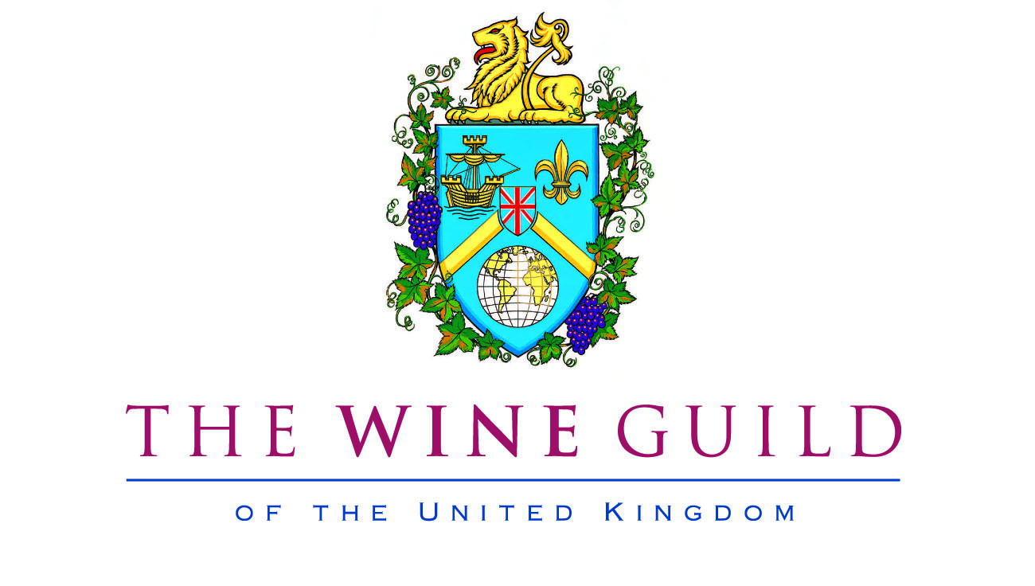

RECEPTION
Ambriel Classic Cuvée 2010, Redford Vineyards, West Sussex

*****

CEREMONY OF INTRONISATION
Skye's English Chardonnay 2015, Hush Heath, Kent

Winner of the
Rothschild Rising Star Award 2016

Mr Jacob Pinder

Finalists of the
Moët UK Sommelier of the Year Competition 2016

Mr Serdar Balkaya
Mr Terry Kandylis (Winner)
Mr Jess Kildetoft

New Member of The Wine Guild

Dr Rory Hill

WINTER BANQUET
Vintners’ Hall - Wednesday, 2nd November 2016

MENU

Seared rainbow trout, duck egg mousse, broadbean pesto, crayfish
Pinot Blanc 2014, Trimbach, Alsace

*****
Aged Herefordshire beef, tarragon truffle choux bun,
oxtail sauce, cauliflower
Kaiserstuhl Pinot Noir, Karl Johner, the Kaiserstuhl, Baden, Germany
The Chocolate Block 2014, Boekenhoutskloof Winery,
Franschhoek, Cape of Good Hope, South Africa

*****
Savoury Foie Gras with apple
Cuvée Beerenauslese 2013, Kracher, Illmitz, Neusiedlersee, Austria

*****

Berry charlotte, cloudberry jam, Kent fizz & caramel
Cuvée Beerenauslese 2013, Kracher, Illmitz, Neusiedlersee, Austria

*****

Coffee & Chocolates

